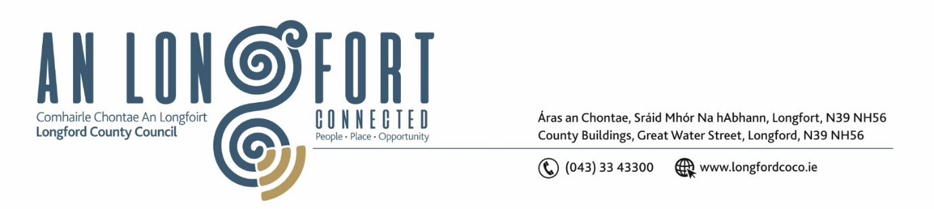**LONGFORD MUNICIPAL DISTRICT**

**Minutes of Meeting of Longford Municipal District held in the Council Chamber Aras an Chontae and via MS Teams on Wednesday, 22 March 2023 at 3.30pm**

**CATHAOIRLEACH**: Councillor Gerry Hagan

**MEMBERS PRESENT**: Councillors – Martin Monaghan, Uruemu Adejinmi, John Browne, Seamus Butler, Peggy Nolan and Gerry Warnock

**IN ATTENDANCE**: Mr. John Brannigan, Director of Services

Mr. Eamonn Bennett, Senior Executive Engineer

Ms. Lorraine Mc Kee, Administrative Officer

Mr. Brian Faughnan, Executive Engineer

Ms. Mary Carey, Healthy Homes Co Ordinator

**MEETINGS**

**ADMINISTRATOR:**  Ms. Claire McNabola

**APOLOGIES:**  None

**PRESENTATION FROM HEALTHY AGE FRIENDLY HOME LOCAL COORDINATOR**

Mary Carey gave a detailed presentation on the Healthy Home Programme. Mary shared case studies with the members and gave them an overview, of how the programme has been evolving in Longford since its commencement.

Mary answered any questions raised by the members.

1. **ADOPTION OF MINUTES – circulated**
2. On the proposal of Councillor John Browne seconded by Councillor Uruemu Adejinmi it was unanimously agreed to adopt Minutes of Meeting of Longford Municipal District held on the 22 February 2023.
3. On the proposal of Councillor Seamus Butler seconded by Councillor Uruemu Adejinmi it was unanimously agreed to adopt Minutes of Committee Meeting of Longford Municipal District held on the 22 February 2023.
4. **MATTERS ARISING FROM MINUTES**

Councillor Seamus Butler requested a timeline on the Greyhound Track Project. John Brannigan replied to say Members will be informed of the proposal as soon as its available. This is a masterplan and will be worked on over a number of years.

1. **DECLARATION OF INTEREST BY MEMBERS**

None

1. **MANAGEMENT REPORT - circulated**

The Management Report, as circulated, was noted.

Councillor John Browne raised the matter of the crash barriers on Lisbrack Road in urgent need of repair or replacement.

1. **CONSIDERATION OF DRAFT BYE LAWS (ROADS)**

A review of (Street Service Vehicles) Bye Laws is currently underway, it is hoped to have draft bye laws in place for consideration at the April Longford MD Meeting, - ahead of the public consultation process. All other bye laws will also be reviewed over the coming months and will factor in Longford Connected changes etc.

1. **NOMINATIONS OF ELECTED MEMBERS FOR THE CREATIVE IRELAND CULTURE TEAM 2023-2027**

On the proposal of Councillor Seamus Butler and seconded by Councillor Gerry Hagan it was agreed to nominate Councillor Uruemu Adejinmi

1. **FUNDING FOR FESTIVALS UPDATE – FUNDING FOR AFRICA DAY EVENT**

Noted

1. **NAMING OF CARRIGLASS ROUNDABOUT**

John Brannigan advised the members of the decision of the Place Naming Committee, which on this occasion was not to name the Carriglass Roundabout as it was not a piece of Major Infrastructure in the County. Members voices their concerns, and request the agenda item be brought back to the Place Naming Committee

1. **CONFIRMATION OF SCHEDULE OF LONGFORD MUNICIPAL DISTRICT WORKS**

On the proposal of Councillor Martin Monaghan seconded by Councillor Seamus Butler, it was unanimously agreed to adopt the Schedule of Longford Municipal District Works, as circulated.

1. **NOTICES OF MOTIONS, SUBMITTED BY COUNCILLORS, AS LISTED HEREUNDER:**

**The following notice of motion was proposed by Councillor Gerry Warnock and seconded by Councillor Peggy Nolan**

I’m calling on Longford Municipal District to place Dog Poop Bins at either end of the Longford Canal Walkway.

**Response**

The Environment Section will review the current positioning of bins along the canal and provide enhanced signage in the area. A communication campaign will be run on social media, which will include a focus on awareness raising of the “leave no trace” and “any bag any bin” initiatives. In addition, the Council will carry out enhanced targeted enforcement, in risk areas this spring, in an effort to improve compliance

**The following notice of motion was proposed by Councillor Uruemu Adejinmi and seconded by Councillor Martin Monaghan**

1. I call on Longford County Council to make it safer for pedestrians accessing Market Square from New Street by implementing a signalised pedestrian crossing at the junction of New Street.

**Response - Eamon Bennett**

We will refer this issue to road design who will review the crossing at the top of New Street to determine if any measures can be put in place to reduce speeds. Should there be an appropriate treatment, Longford County Council will apply for funding under Low-cost Safety Scheme.

**The following notice of motion was proposed by Councillor Uruemu Adejinmi and seconded by Councillor Seamus Butler**

1. I call on Longford County Council to contact the Five Star Pizza business owner and the Landlord to relocate the bins left permanently on the public access area of Garvey's Yard. The location of the bins results in rubbish left scattered around them making the area unsightly and a health and safety risk, causing great distress to residents and people accessing the Annaly carpark via Garvey’s Yard.

**Response**

Longford County Council are aware of the instance noted in this NoM and are actively working to remedy this situation. Staff of the Environment Department carry out regular patrols and clean ups in this area. The business owner has been advised of their legal obligations in relation to waste management and litter prevention. Longford County Council is in the process of taking enforcement action.

This concluded the business of the meeting.

**Signed: ____________________**

**Claire McNabola,**

**Meetings Administrator.**

**Confirmed and adopted at Longford Municipal District Meeting held on the 3 May 2023.**

**Signed: _______________**

**Cathaoirleach.**